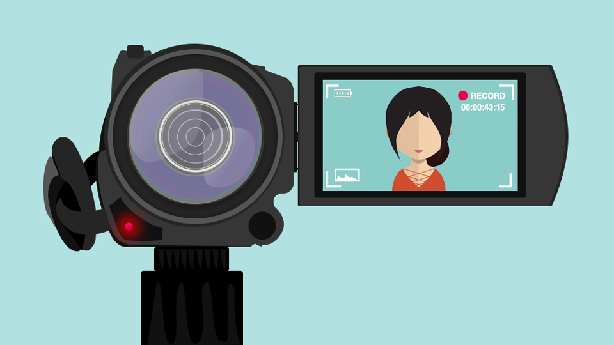
Vlog assignment
It is important to get to know each other before you get started on the project. That's why you are going to make a vlog, to tell your partner student a bit more about you!

Before you start filming, make sure you have fully read the assignment and thought about what you are going to say and show in your vlog. You don’t have to make a script (it’s supposed to be spontaneous), but some talking points might come in handy.

Step 1 - introduction, who are you?
Take the first 1-2 minutes of the video to introduce yourself. Think about the following questions:
- What's your name and how old are you?
- Where do you live? What kind of place is that? Do you live far from your school and how do you get there?
- Tell something about your family. Do you have brothers or sisters?
- What hobbies do you have?
- What music, series and sports do you like?
- What are your favorite and least favorite school subjects?
- What are your plans for the future?

Step 2 - on location
Take the next 1-2 minutes to show a place that’s important to you. Explain why this place is important and what it means to you. Some suggestions:
- sports club
- city centre (shops, cinema, etc.)
- school
- your neighbourhood
- family
- place where you meet friends

Step 3 - ending
End by saying what you expect or hope to gain from the project.

Some tips
Here are some easy to follow tips that can help you to take your vlog to the next level. Perhaps unsurprisingly, YouTube is full of vlogs about how to vlog, so feel free to have a look there as well.
How to VLOG on your Phone - 5 Tips for Beginners
How to Vlog: Beginners Guide - 5 Simple Tips

