"Food, Cultural Heritage and Sustainable Development"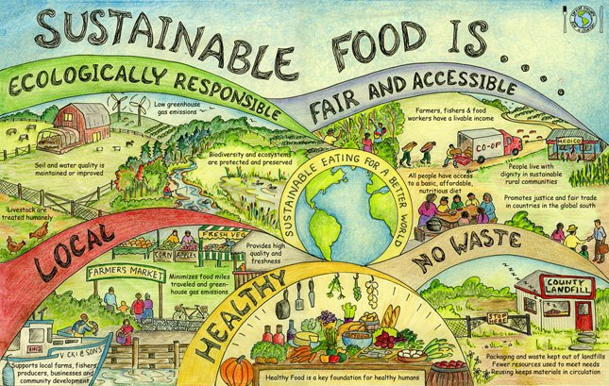
During the exchange project between Fiorenzuola, Parma and Warnsveld you will learn many things about each other’s countries, about different schools, and about different cultures. You will find that there are many differences between our two countries. However, there are also many things that we share. Both Italy and the Netherlands are dealing with global issues, such as climate change and the challenge to feed the population in a sustainable and healthy way. If we want to tackle these challenges we need to work together. That is why we embrace the spirit of European cooperation.

This year, the exchange project will focus on making a positive impact in your own communities in Italy and in the Netherlands. How can you encourage people to eat healthy? What can we do to preserve local food culture? In what way can you inform people about the link between their diets and global warming? The goal of this project is that you develop your own tools, which means that you are not only going to think of solutions, you are going to put these into practise.

- Below you will find the steps that you need to take during the assignment. On Thursday you will pitch your plan to your fellow students. At the end of each step you will find what you need to include in your pitch. You will find an overview of your pitch requirements at the end of the assignment.

Step 1 - groups
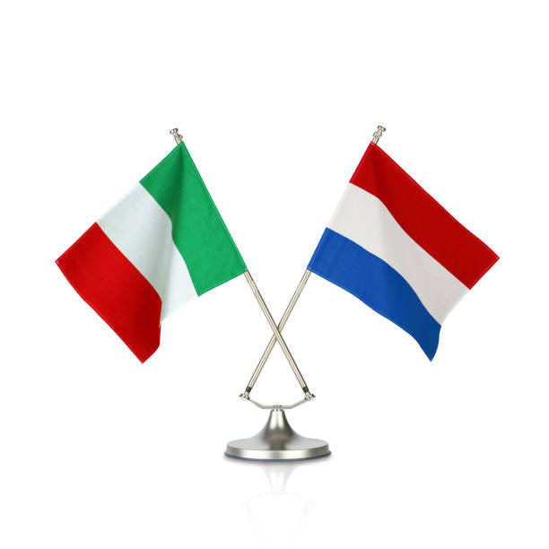
You will work together in these groups for the duration of the exchange project.

→ Part 1 of your pitch: introduce your group mates!

Step 2 - Picking a topic
You are going to be the change you want to see in the environment! First of all it is important to pick a topic that you feel needs to be addressed. Pick a topic that motivates you to take action. Below you see a list of topics from which you can choose. It is also possible to pick your own topic. While picking your topic please remember that eventually you need to create (and carry out) practical solutions to the environmental problem that you chose. We call this the intervention. Consult your teacher about the topic you have chosen.

→ your pitch: explain why you chose the topic and why it is important in both countries. Do some research and give a general description of the issue. Describe the goal that you want to achieve at the end of this project.

Topics | Pointers
Plastic soup  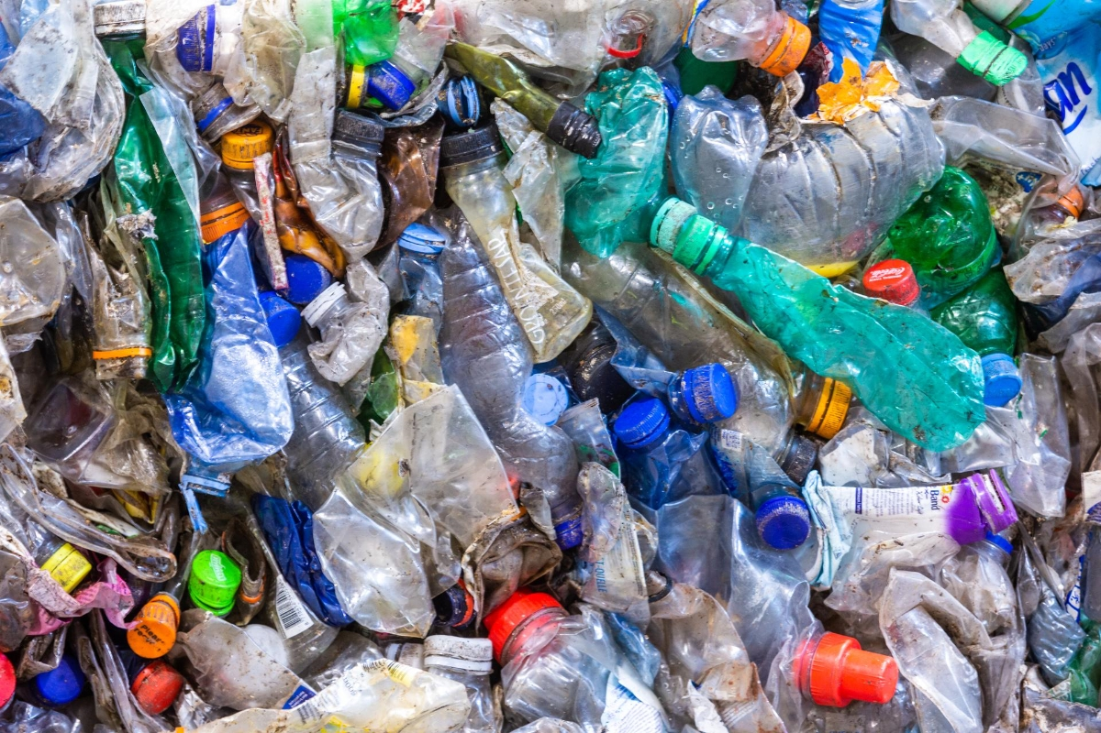 | You can focus on addressing the cause of plastic soup (picking up trash in your neighbourhood, banning plastic bags, promoting recycling or bio plastic), but also the effects (how to clean the existing plastic soup)
Eating less meat  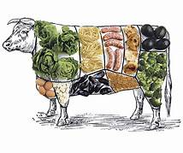 | How does the consumption of meat affect animal welfare, the climate, and public health? What needs to be done to change people’s diets and switch to a different source of protein, such as insects?
Local/biological vegetables  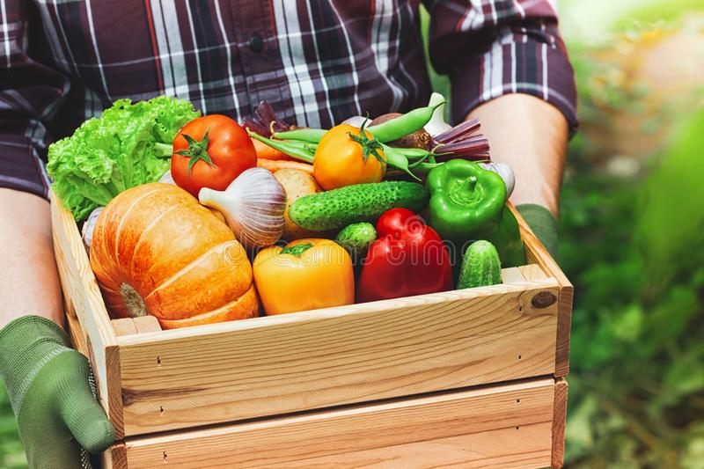 | How does eating locally grown fruits and vegetables affect transport, air quality, global warming, and the local economy? What benefit does biological farming have for nature?
Transport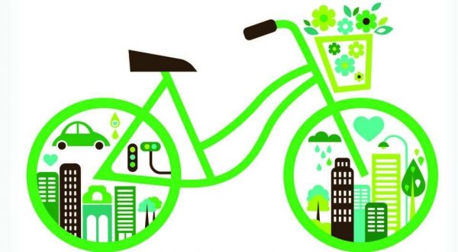 | How can different means of transport improve air quality and public health, and how will it help limit climate change?
Sustainable economy  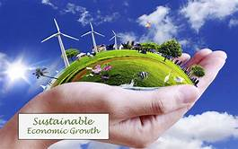 | How can you earn money without harming the planet? Can you make money with your own sustainable business model?
Raising awareness  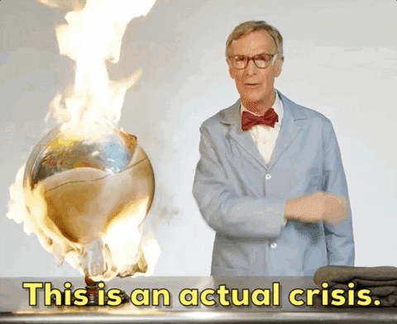 | You already know what should be done, but how can you make others change their behaviour?
Ecosystems  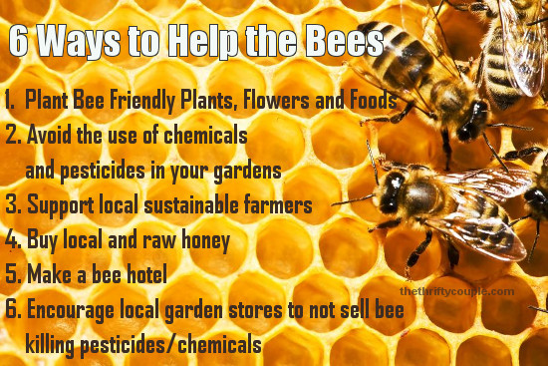 | In many places nature is under threat, many animal and plant species are at risk of going extinct. How can we allow local forests and other parts of nature to flourish again? And why do you think that’s important?
Global impact of technology   | Cellphones, iPads, laptops and electric cars all depend on scarce minerals for their components. Mining these minerals can have disastrous effects on nature and be a source of conflict in local communities. How can we make sure resources are mined in a more responsible and more products are recycled?
Technology and lifestyle   | What is the impact of pc, email, whatsapp on our daily lives? How can we prevent losing ourselves in our phones?
Responsible fashion   | The fashion industry produces 10% of all humanity’s carbon emissions, is the second-largest consumer of the world’s water supply, and pollutes the oceans with microplastics. What can be done to change things for the better?
Own topic  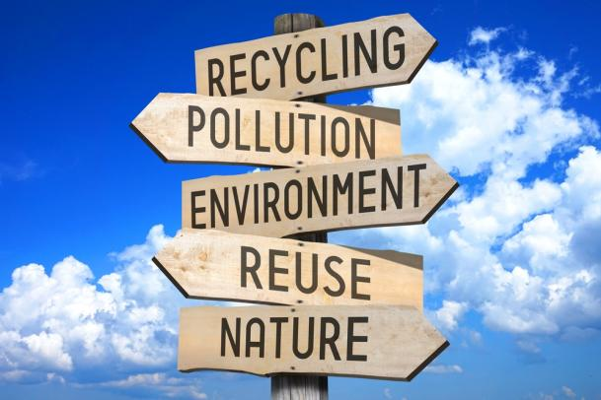 | You can also think of your own topic. Make sure it has to do with an environmental problem. Please consult with your teacher before moving forward.

Step 3 - Practical solutions
The next step is to create a practical solution (the intervention) that you will put into practice in your own community in Italy and the Netherlands. The solution has to be SMART: Specific, Measurable, Achievable, Realistic, Timely. We might add an extra S, for keeping it Simple. Does your intervention fit these criteria? If not, your can try a different approach.

An example: you might consider asking the Minister of Environment to change his policy, let’s say banning plastic packaging. However, a one-on-one conversation is unlikely to happen (not achievable), and an email is unlikely to change his behaviour (not realistic). Instead, organising a petition (eg at a local supermarket) to raise awareness might be a more achievable and realistic way to get where you want to be.

Next, you need to describe the intervention in detail. Answer the following questions:
- Why did you choose this intervention?
- How are you going to do this?
- Who is going to do what and when?
- What do you need to carry out the intervention?
- What barriers do you see and how can you overcome them?
- What opportunities do you see and how will you use these?

→ part 3 of the pitch. Present the intervention using your answers to the questions above.

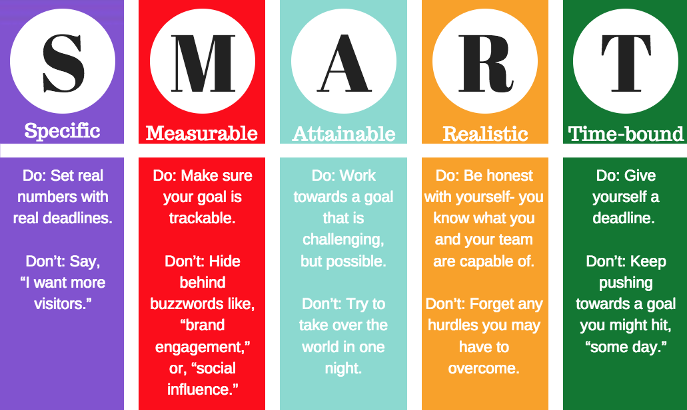

Step 4 - Plan of action
You need to know who does what and when, therefore you need a plan of action. A timeline [from now until the exchange week in the Netherlands]. In it, you write who is going to what and when. It should contain the following:

- Task division. Make sure to give a detailed description of each task, make sure to include: group coordinator, Dutch coordinator, Italian coordinator. Other tasks can be: artistic director, pr, logistics, etc. Make sure that tasks are evenly divided throughout the duration of the project.
- Set some intermediary goals for your project, 'by … this should be achieved'
- plan some moments to meet online with your group.
- plan moments when you are going to consult with your tutor/teacher.

→ part 4 of the pitch. Present your plan of action, covering all the bullet points above.
.

Requirements pitch Thursday, November 7
After finalising step 1 until 4 you have a project proposal. During the pitch you present this project proposal to your peers.

Your pitch should include the following:
- Part 1 of your pitch: introduce your group mates!
- Part 2 of your pitch: explain why you chose the topic and why it is important in both Italy and the Netherlands. Do some research and give a general description of the issue. Describe the goal that you want to achieve at the end of this project.
- Part 3 of the pitch. Present the three actions using your answers to the questions listed in step 3.
- Part 4 of the pitch. Present your plan of action, covering all the bullet points listed in step 4

Don’t forget
- Your pitch should be short and to the point (around 5 minutes), and it should be focused on receiving feedback from your audience. Make sure to ask for input and feedback from your audience, they can help you to further improve your project.
- After the pitch you improve your project proposal and do a final check with your teacher/tutor.

