Overview of Erasmus project Italy-NL

week in Italy (week 45, 3-8 November)
Schedule for bus driver
Example of assignment Isendoorn & Czech schools
"Food, Cultural Heritage and Sustainable Development"
Step 1 - groups
Step 2 - Picking a topic
Step 3 - Practical solutions
Step 4 - Plan of action
Step 5 - action between exchange weeks
Requirements pitch Thursday, October 17

week in Italy (week 45, 3-8 November)
Sunday
7:00 departure Warnsveld
20:00 arrival Fiorenzuola
21:00 arrival Parma Scuola per l’Europa

Monday:
- getting to know the school/city?
- Project?
I think we need at least two half-days (if that’s a word) for the project (e.g. one morning for making teams and writing a proposal, and later in the week an afternoon for pitching proposal and peer feedback)

Tuesday:
- Fiorenzuola use Dutch bus (visit abbey and a company processing fruit and vegetables)

Wednesday
- Bus used for Parma (Bertolucci) visit to Bologna,
- Fiorenzuola en Parma L’Europa also visit Bologna, they use other busses

Thursday
- evening: departure for the Netherlands. We will leave Parma around 17:00, Fiorenzuola around 18:00

On Thursday the Dutch bus cannot be used for other activities (resting time driver = minimum 9 hours).

Friday
Early afternoon: arrival in Warnsveld

Schedule for bus driver
Can you let me know what other days the Dutch bus is needed (+ times and locations)?

Sunday | trip to Italy + minimum 9 hours resting time for driver  drop off Fiorenzuola: Cappuccini Shopping Centre (J.F.Kennedy street)  drop off Parma: Scuola per L’Europa
Monday | not used
Tuesday | used by Fiorenzuola + guests to visit abbey  On Tuesday we will need the bus to be in Fiorenzuola at 9.00 - at the parking lot in front of Cappuccini Shopping Centre (J.F.Kennedy street): this is the place where the bus will also stop to drop off the students (and also pick them up on Thursday 7th  first stop will be a nearby abbey - Chiaravalle della Colomba - for 1h / 1h 1/2 - then a second stop in Soarza di Villanova (some 20 km to go) for the visit to the processing firm.  Prospected time back to school: 13 /13:15
Wednesday | used by Parma Bertollucci + guests to visit Bologna
Thursday | trip back to NL, other use is not possible  Pick up Parma: Scuola per L’Europa and Liceo Bertolucci on the way to the motorway  Pick up Fiorenzuola: Cappuccini Shopping Centre (J.F.Kennedy street)

- Financial aspects
The Dutch Erasmus authority is not so strict regarding finances, as long as we organise two exchange weeks with enough students (current numbers are more than enough) and the project achieves its desired impact, we should be okay. It is important to hand out certificates (hosting school) with each exchange week in order to earn the grant.

Is it okay if we keep the same practice as before? Travel to and from the exchange week is paid by the visiting school, all expenses during the exchange week are covered by the hosting school (accommodation/meals for teachers, costs related to excursions/activities for students)

- assignment for students
General
Dutch and Italian students work on a practical solution to a problem related to food and the environment or promoting cultural heritage related to food. This must result in a concrete action (intervention) in their own community.

Before visit Italy
Getting to know each other (through eTwinning), exchanging some info related to local culture/food/environment.

week in Italy
introduction, forming teams, designing intervention and, devising plan of action, setting goals (when is the project successful), identifying possible barriers/partners in local community.

- what groups do we make (size, composition) max. 6 students (3 NL, 3 Ita)
- Everyone has a role/clear task (no one can hide)
- Dividing groups according to skill. Getting to know each other activity. Students enter their skills in form, we need six roles (HR, PR,)
- Would it be possible to mix the Italian students as well? (no, too difficult)

Isendoorn | Italy
3tvq - 24 students | Parma Scuola per L’Europa -
3tvr - 23 students | Parma Liceo Bertolucci -
3tvt - 25 students | Fiorenzuola Mattei -

In-between exchange weeks:
Implementing solution in local community in Italy and the Netherlands, sharing results (eTwinning), improving intervention.

There is some money which we could use to support students in carrying out their intervention, do we want to give them a certain budget for this. If so, do we want to set rules/limits to that at this time (or later).

Leave the money for now. If student need extra funds to carry out their project we can offer them financial assistance later.

Week in NL: evaluation and dissemination of outcomes

- matches Italian students

- Possible topics for students to choose from

I think it would be good to offer students some ideas for topics to choose, but they should also have the option to propose their own topic. Do you any ideas for topics that we can add here?

Ideas for topics | Comments
- plastic packaging | Solution can focus on either the cause (picking up trash, banning plastic bags, promoting recycling) and effects (filtering plastic from local water, promoting bio plastic that will bio degrade)
- More sustainable diets | Focus on either environmental effects or animal welfare, switching between types of meat (from beef to chicken for example), eating different kinds of protein (insects).  supporting lower income groups in maintaining healthy diets
- local vegetables | Less transport, vegetables/fruits of the season, less toxins used for pest control.
- cultural heritage of food | Parma ham & cheese, traditional Dutch and Italian food.
- growing your own food | Urban farming, circular farming
- the role of the ecosystem in food production | supporting birds and bees

assignment Isendoorn & Italian schools

Below is the assignment that we used last week to start another Erasmus project between Isendoorn College and two Czech schools. We could use this as a basis for the project that our students will start in Italy and finalise in the Netherlands. I have adapted it to Italian-Dutch project. It is not set in stone. We have to adapt it to fit the topic of food, cultural heritage and sustainable development, and the context of the visits to Italy and the Netherlands.

→ Could you have a look at it and see what you think (using the comments/suggestions function)?

"Food, Cultural Heritage and Sustainable Development"
During the exchange project between Fiorenzuola, Parma and Warnsveld you will learn many things about each other’s countries, about different schools, and about different cultures. You will find that there are many differences between our two countries. However, there are also many things that we share. Both Italy and in the Netherlands are dealing with global issues, such as climate change and the challenge to feed the population in a sustainable and healthy way. If we want to tackle these challenges we need to work together. That is why we embrace the spirit of European cooperation.

This year, the exchange project will focus on making a positive impact in your own communities in Italy and in the Netherlands. How can you encourage people to eat healthy? What can we do to preserve local food culture? In what way can you inform people about the link between their diets and global warming? The goal of this project is that you develop your own tools, which means that you are not only going to think of solutions, you are going to put these into practise.

- Below you will find the steps that you need to take during the assignment. On Thursday you will pitch your plan to your fellow students. At the end of each step you will find what you need to include in your pitch. You will find an overview of your pitch requirements at the end of the assignment.

Step 1 - groups
The groups are made by the Italian schools. You will work together in these groups for the duration of the exchange project.

→ Part 1 of your pitch: introduce your group mates!

Step 2 - Picking a topic
You are going to be the change you want to see in the environment! First of all it is important to pick a topic that you feel needs to be addressed. Pick a topic that motivates you to take action. Below you see a list of topics from which you can choose. It is also possible to pick your own topic. While picking your topic please remember that eventually you need to create (and carry out) practical solution to the environmental problem that you chose. We call this the intervention. Consult your teacher about the topic you have chosen.

→ Part 2 of your pitch: explain why you chose the topic and why it is important in both countries. Do some research and give a general description of the issue. Describe the goal that you want to achieve at the end of this project.

Topics | Pointers
Plastic soup | You can focus on addressing the cause of plastic soup (picking up trash in your neighbourhood, banning plastic bags, promoting recycling or bio plastic), but also the effects (how to clean the existing plastic soup)
Eating less meat | How does the consumption of meat affect animal welfare, the climate, and public health? What needs to be done to change people’s diets and switch to a different source of protein, such as insects?
Local/biological vegetables | How does eating locally grown fruits and vegetables effect transport, air quality, global warming, and the local economy? What benefit does biological farming have for nature?
Transport | How can different means of transport improve air quality and public health, and how will it help limit climate change?
Sustainable economy | How can you earn money without harming the planet? Can you make money with your own sustainable business model?
Raising awareness | You already know what should be done, but how can you make others change their behaviour?
Ecosystems | In many places nature is under threat? How can we allow local forests and other parts of nature to flourish again? And why do you think that’s important?
Own topic | You can also think of your own topic. Make sure it has to do with an environmental problem. Please consult with your teacher before moving forward.

Step 3 - Practical solutions
The next step is to create a practical solution (the intervention) that you will put into practice in your own community in Italy and the Netherlands. The solution has to be SMART: Specific, Measurable, Achievable, Realistic, Timely. We might add an extra S, for keeping it Simple. Does your intervention fit these criteria? If not, your can try a different approach.

An example: you might consider asking the Minister of Environment to change his policy, let’s say banning plastic packaging. However, a one-on-one conversation is unlikely to happen (not achievable), and an email is unlikely to change his behaviour (not realistic). Instead, organising a petition (eg at a local supermarket) to raise awareness might be a more achievable and realistic way to get where you want to be.

Next, you need to describe the intervention in detail. Answer the following questions:
- Why did you choose this intervention?
- How are you going to do this?
- Who is going to do what and when?
- What do you need to carry out the intervention?
- What barriers do you see and how can you overcome them?
- What opportunities do you see and how will you use these?

→ part 3 of the pitch. Present the intervention using your answers to the questions above.

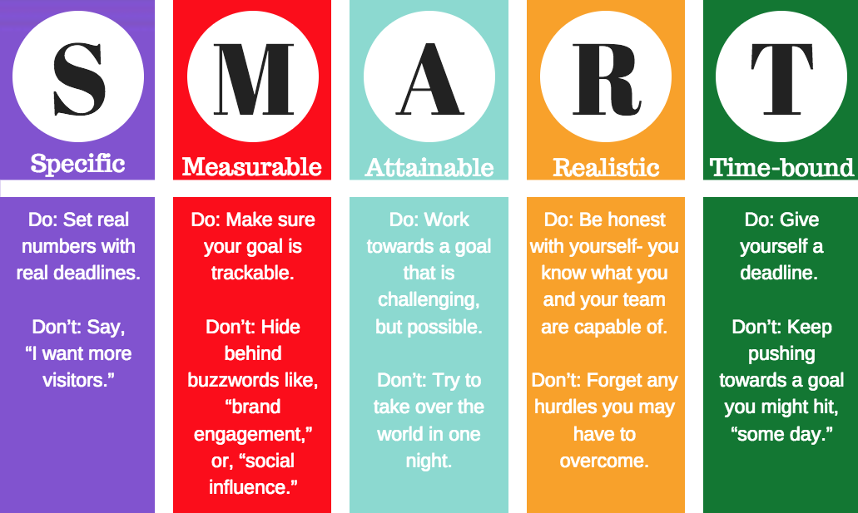

Step 4 - Plan of action
You need to know who does what and when, therefore you need a plan of action. A timeline from now until the exchange week in the Netherlands. In it, you write who is going to what and when. It should contain the following:

- Task division. Make sure to give a detailed description of each task, make sure to include: group coordinator, Dutch coordinator, Italian coordinator. Other tasks can be: artistic director, pr, logistics, etc. Make sure that tasks are evenly divided throughout the duration of the project.
- Set some intermediary goals for your project, 'by … this should be achieved'
- plan some moments to meet online with your group.
- plan moments when you are going to consult with your tutor/teacher.

→ part 4 of the pitch. Present your plan of action, covering all the bullet points above.

Step 5 - action between exchange weeks
After this first exchange week you are going to put your plans into action. Make sure to use the plan of action you made earlier, and keep in touch with your group mates to discuss the progress on your intervention. Your tutor/teacher will be able to help you when necessary, but it's up to you to consult with him/her.

→ Task: during the exchange week in the Netherlands you have to present the work that you have done. Make sure to keep a (video) logbook that you can present during this week.

Step 6 - exchange week in Netherlands
During the week in the the Netherlands the outcomes of the project will be evaluated and shared with the wider community.

Requirements pitch Thursday, November 7
After finalising step 1 until 4 you have a project proposal. During the pitch you present this project proposal to your peers.

Your pitch should include the following:
- Part 1 of your pitch: introduce your group mates!
- Part 2 of your pitch: explain why you chose the topic and why it is important in both Italy and the Netherlands. Do some research and give a general description of the issue. Describe the goal that you want to achieve at the end of this project.
- Part 3 of the pitch. Present the three actions using your answers to the questions listed in step 3.
- Part 4 of the pitch. Present your plan of action, covering all the bullet points listed in step 4

Don’t forget
- Your pitch should be short and to the point (around 5 minutes), and it should be focused on receiving feedback from your audience. Make sure to ask for input and feedback from your audience, they can help you to further improve your project.
- After the pitch you improve your project proposal and do a final check with your teacher/tutor.

