

My Exchange report

Why this report?
Spending a week on your own in a foreign place, a foreign house, with, initially, foreign people is quite an adventure. It will be challenging & exciting and can be both scary & uncomfortable but also thrilling and wonderful.
Whatever happens, you will all get to know a lot about each other’s way of life, school, culture, food, etc.
Writing a report will help you give shape to all this and help you keep track of your personal development. The lay out of your digital report should be attractive. It should be a reader-friendly and complete piece of work, written with care and enthusiasm. Language-wise, sentence structure, grammar, vocabulary and spelling should be correct. It should be added to your isendoorn portfolio.nl.

When?
During both exchange weeks, you will be given the opportunity to collect material and work on your tasks. Moreover, you will be allowed time in “mentorles”. Your tutor will set you a deadline for the final report, sometime after the second week. After it has been assessed and, if necessary, revised, you can upload this file full of memories in your Isendoorn Portfolio (tab: My international experience, tag: Exchange)

How?
Copy this document and personalize it. Before, during and after both weeks you will add all required material, info, pictures, tasks, etc. Feel free to add pictures everywhere, or include them in the Picture Gallery below.

The lay out of your digital report should be attractive. It should be a reader-friendly and complete piece of work, written with care and enthusiasm. Language-wise, sentence structure, grammar, vocabulary and spelling should be correct. After it has been assessed and, if necessary, revised, you can upload this file full of memories in your Isendoorn Portfolio (https://portfolio.isendoorn.nl/ tab: My international experience, tag: Exchange)

Covid…..
Luckily, we will be able to travel again and join in a new Exchange. However, Covid is still there, which means we have to respect and adjust to all sorts of rules and regulations, both in The Netherlands and in the hosting country. Obviously, you will encounter situations that may be challenging, but also interesting, especially if you consider the different attitudes people may have towards the covid situation. This Exchange report will not be complete without references to your covid experience, so whenever you can, incorporate them in your answers to the questions.

Week 1: my trip to ……


Visually represent the geographical location of your Exchange destination. Include environmental characteristics, eg mountains, lakes, woods, beaches, industry, city life/buildings, etc.:

My Exchange destination:

Expectations: which 3 things do you expect to experience during the entire exchange?
1.

2.

3.

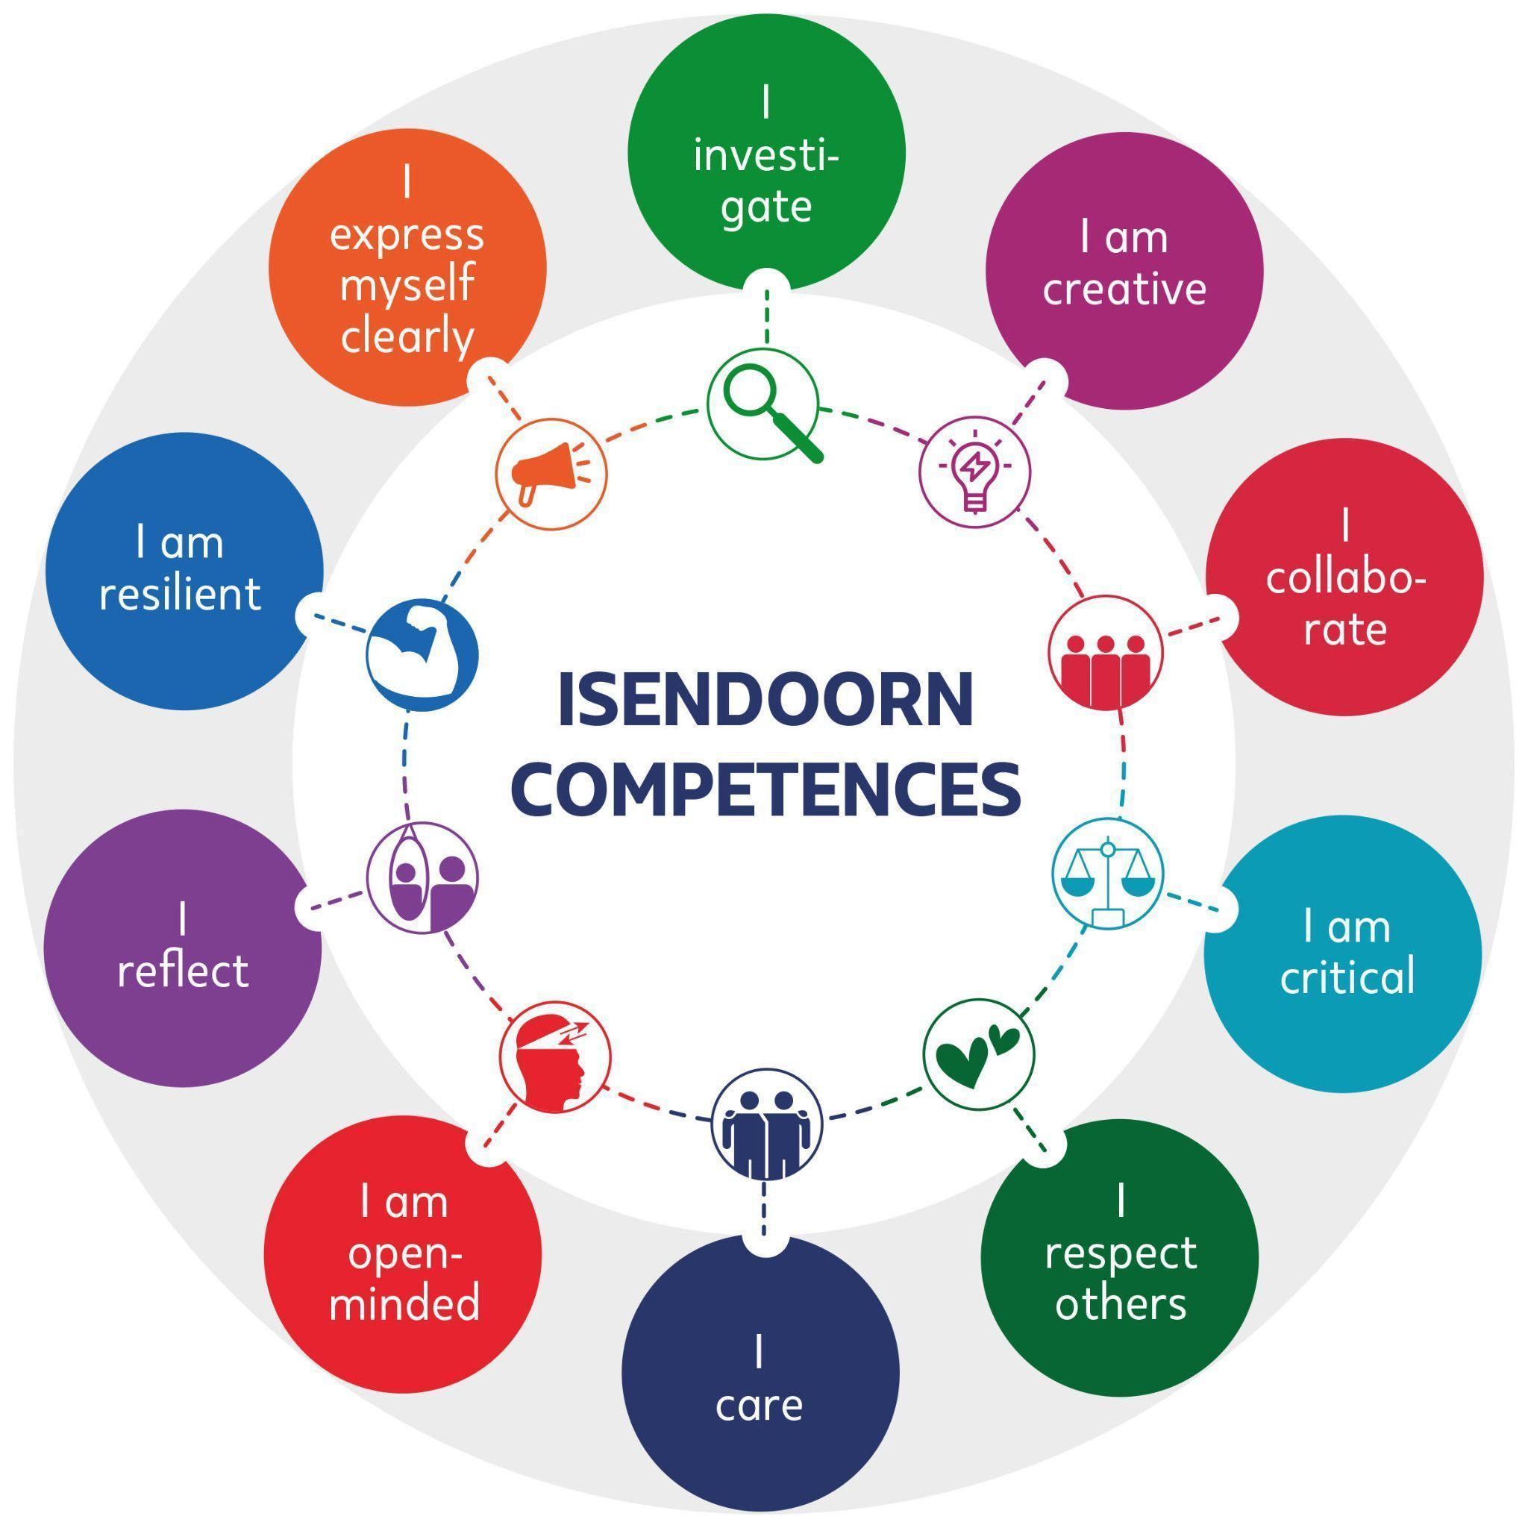
Which 3 Isendoorn competences will be useful for you in the exchange? Why?
1.

2.

3.

After you get back:

Include a picture of you and your match/host here:

Draw a mindmap or make a collage in which you visually represent the two of you.
Include, for example, the following basic facts of both of you:
age, gender, family, parent professions, housing, school, hobbies, favourite music, favourite food, friends, languages, favourite subject, fashion, special interests, etc., :


Food: write a paragraph on the foreign dishes you were served during the week abroad. Include a comparison to your own home food and describe your likes and dislikes.


Language: write a paragraph on how you communicated with your match, his or her family, friends, etc. Include obstacles, if there were any, and describe solutions.

What was it like to stay with a family, perhaps even all by yourself, you’ve never met before?

Highlights: describe at least 3 highlights of your exchange trip abroad:

1.

2.

3.

Week 2: taking care of our guests

Tips:
- organize a bike and/or alternative transport for the week
- record a video tour of your house and home mates and share with him/her
- think about how to spend your free time with your match(es)

Programme: tasks for pairs/groups (to be carried out in mentorles and at home) to be discussed with your mentor:

- Treasure hunt/phototour in Zutphen for 4 (big) groups
- Social media wizzard: student pair will take pictures/films for the school’s Insta
account. Share with ltk.
- Organic Dinner Club: divide tasks, make sure everyone does their bit
- Film: a Day in the Life of a Dutch Teenager
- Ik Hou van Holland: Language quiz
- The Netherlands in a nutshell: informative ánd engaging PPT
Which of the above activities/presentations are you involved in? Describe it here:

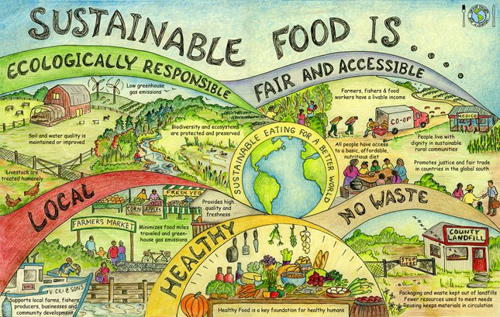
Sustainability Project
During the exchange you work on an overarching project on the topic of sustainability. Please make sure to include your material of this in your exchange report.
Our Sustainability project:

After they’ve left….
In case you hosted a student:
How did you experience your role as a host to your match? What was positive, what was challenging/difficult?

What did you do together with our visitors during your free time?

Describe at least 3 highlights of the second week:
1.
2.
3.

Rounding off the Exchange

Your mentor may propose the following:
Preparing a presentation of your two-week exchange in groups of around 3. Choose your own format to review & present your experience. For example, a sketch, a clip, a song, a rap, a dance, a blog, a fairy tale, a diary, etc. Your mentor will ask some of you to deliver this presentation to your parents, too, on the final parents’ evening of this year, The TTO Junior Certificate Celebration.

My Exchange Picture Gallery

3(t)hv Exchange Report & Presentation Assessment Rubric
(to be filled in by your mentor)
Criteria: | Report (1-5 points):
Content: to what extent is the product truly personal & reflective, that is, not just descriptive but also the result of your own serious thought and consideration
Completeness
Organisation & lay-out; text and pictures!
Originality/creativity
Use of English
Presentation (group)
Total number of points

